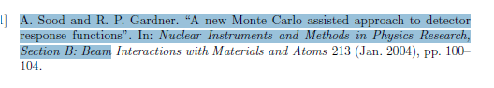

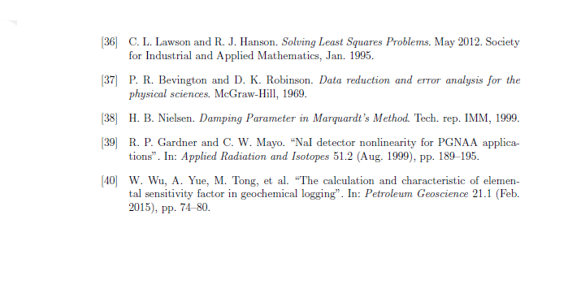

* Bob Burkhart, “Neutron Generator and Well Logging”, Sandia National Laboratories, SAND2006-3291C, [www.osti.gov/servlets/purl/1264595](http://www.osti.gov/servlets/purl/1264595)
* Committee on Radiation Source and Replacement, 2008, Radiation Source Use and Replacement, National Research Council, ISBN 0-309-110115-7, National Academies Press, Washington, DC (NAS-2008)
* Gardner, et al., 2013, ANS Panel on “Recent Developments in Radiation Source Use and Replacement after the NAS Report of 2008”, Transactions of the American Nuclear Society, Vol. 109, 47.
* Liberman, A.D et. al., “A method to determine the absolute neutron output of small D-T generator”, *Nuclear Instruments and Methods in Physics Research Section B,* Volume 79, Issue 1-4, p. 574-578, June 1993
* Preston R.M. et al, “Neutron generator burst timing measured using a pulse shape discrimination plastic scintillator with silicon photomultiplier readout”, *Journal of Instrumentation*, December 8, 2013
* U.S. Total Crude Oil and Petroleum Products, *U.S. Geological Survey*, www.usgs.gov, accessed February 2018